CITIZEN
🧠 1️⃣ Instant Situation Awareness (এক নজরে অবস্থা বোঝা)
👉 User dashboard খুলেই দেখে:
- Total cases
- High risk area
- Nearby hospitals
✔️ মানে তাকে আলাদা কোথাও যেতে হচ্ছে না
✔️ সাথে সাথে বুঝে যাচ্ছে situation serious কিনা

🗺️ 2️⃣ Smart Map Understanding (সবচেয়ে powerful feature)
👉 Map এ user যা পাচ্ছে:
🌈 Risk বুঝতে পারছে:
- 🔴 Red → danger
- 🟡 Yellow → moderate
- 🟢 Green → safe
📍 Help কোথায় আছে:
- 🏥 Hospital
- 👨‍⚕️ Doctor
- 🩸 Donor
✔️ Result:
👉 User instantly decision নিতে পারছে
👉 “আমি safe না risk এ?” + “help কোথায় পাব?”

🚑 3️⃣ Emergency Support (life-saving feature)
👉 Dashboard থেকেই user পাচ্ছে:
- Hospital number
- Doctor number
- Donor number
✔️ এক click এ call করতে পারবে
✔️ emergency তে time save হবে

🧾 4️⃣ Community Reporting সুবিধা
👉 User করতে পারছে:
- Breeding site report
- Symptoms report
✔️ এতে:
- Government data পাচ্ছে
- Community help করছে
👉 user feel করে সে system এর part ✔️

🔔 5️⃣ Real-time Alerts
👉 Latest alerts section:
- Outbreak warning
- Precaution advice
✔️ User updated থাকছে
✔️ আগে থেকেই সাবধান হতে পারছে

🩸 6️⃣ Donor System Benefit
👉 User donor খুঁজতে পারছে easily
👉 Donor number দেখছে
✔️ emergency blood shortage solve করতে help করছে

👤 7️⃣ Personal Control (Profile + Donor toggle)
👉 User control পাচ্ছে:
- নিজের profile
- Donor হবে কিনা
✔️ flexibility আছে
✔️ আলাদা account দরকার নাই

⚡ 8️⃣ Time Saving System
👉 সব এক জায়গায়:
- Map
- Report
- Hospital
- Alerts
✔️ multiple app দরকার নাই
✔️ fast response possible

🎯 9️⃣ Decision Making Easy
👉 Example:
- Area red → danger
- Nearby hospital + donor → visible
✔️ User instantly decide করতে পারছে:
👉 “এখনই doctor দেখাবো”

🌍 10️⃣ Real Impact (Big Picture)
👉 একজন user:
- সচেতন হচ্ছে
- safe থাকছে
- অন্যকে help করছে
👉 পুরো system:
✔ community driven
✔ healthcare connected

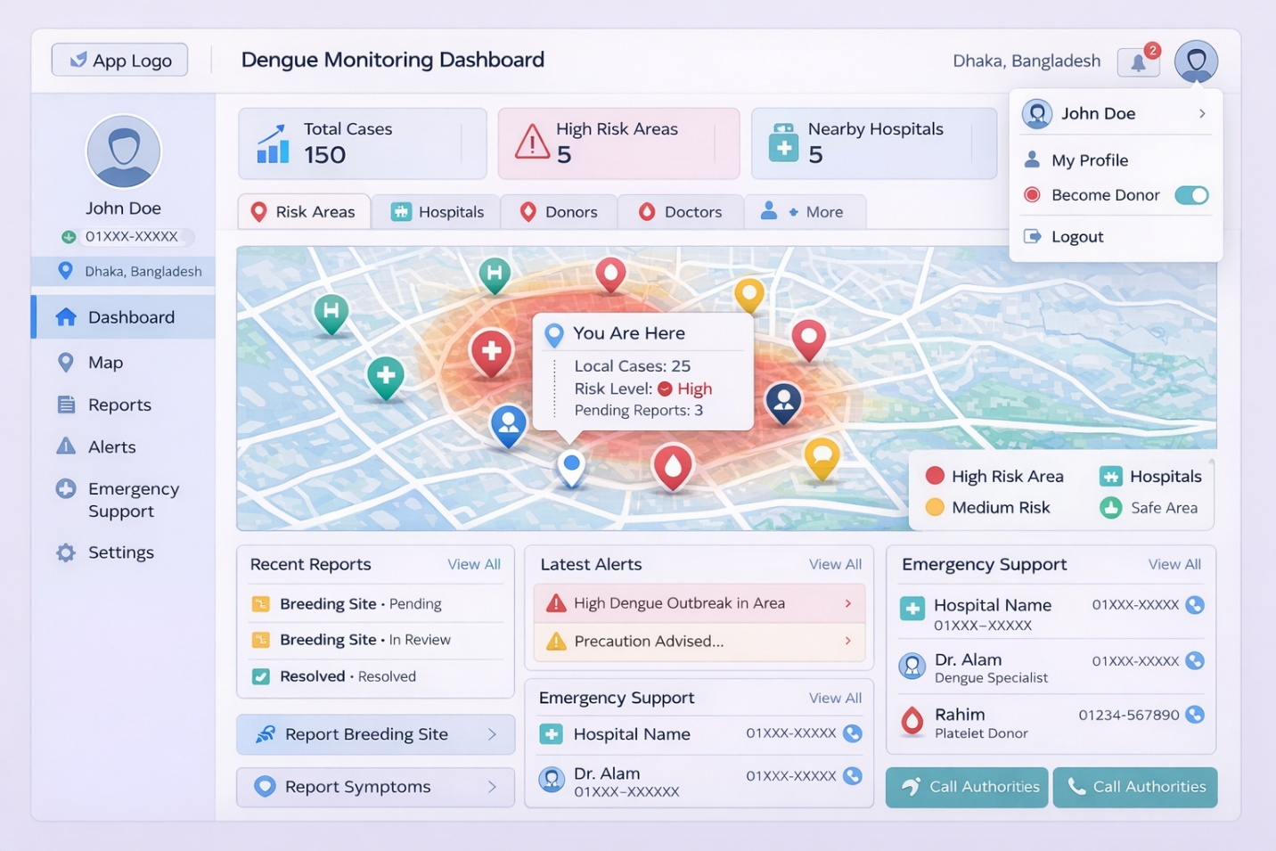
✅ Final Summary
👉 এই dashboard user কে দেয়:
✔ Awareness
✔ Safety
✔ Emergency support
✔ Community participation
✔ Quick decision power

Admin / Health Officer
🧠 1️⃣ Full Situation Control (সবকিছু এক জায়গায়)
👉 Admin এক নজরে দেখতে পাচ্ছে:
- Total dengue cases
- High-risk zones
- Total users
- Active donors
✔️ মানে:
👉 পুরো city health status instantly clear
👉 decision নিতে delay নাই

🗺️ 2️⃣ Smart Map Control (system এর brain 🔥)
👉 Map এখন শুধু view না — control tool
Admin যা করতে পারছে:
- Risk zone identify (Red/Yellow/Green)
- Hospital / Doctor / Donor location দেখা
- Map click করে action নেওয়া
✔️ Result:
👉 কোন এলাকায় outbreak হচ্ছে → instantly detect
👉 সাথে সাথে action plan করা

📍 3️⃣ Resource Visibility (Huge advantage)
👉 Admin দেখতে পাচ্ছে:
- 🏥 Hospitals
- 🩸 Donors
- 👨‍⚕️ Doctors
✔️ শুধু location না:
👉 availability (donor, beds etc.)
👉 Example:
“এই এলাকায় donor কম → alert পাঠাতে হবে”

🧑‍🤝‍🧑 4️⃣ User & Donor Management
👉 Admin control পাচ্ছে:
- সব user list
- donor filter
- donor availability
✔️ Donor আলাদা system না লাগায়:
👉 সব centralized ✔️

📝 5️⃣ Report Verification System
👉 Admin পাচ্ছে:
- Breeding site reports
- Image proof
- Location
Action:
- ✔ Verify
- ❌ Reject
✔️ এতে:
👉 fake report কমে
👉 real data improve হয়

🚜 6️⃣ Field Operation Control (real government feature 🔥)
👉 Admin করতে পারছে:
- Fogging schedule
- Area assign
- Field team assign
✔️ Result:
👉 Action directly track করা যাচ্ছে

📊 7️⃣ Data Analytics & Trends
👉 Admin দেখতে পাচ্ছে:
- Case trend (weekly/monthly)
- Area-wise outbreak
- Donor availability
✔️ Data-driven decision possible

🔔 8️⃣ Alert & Communication System
👉 Admin send করতে পারছে:
- Outbreak alert
- Area warning
- Emergency donor request
✔️ Example:
“Urgent O+ donor needed in Mirpur”

🚑 9️⃣ Emergency Resource Monitoring
👉 Admin real-time দেখছে:
- Hospital availability
- Donor count
- Bed availability
✔️ Crisis management easy

⚡ 10️⃣ Quick Action Buttons (Fast Response System)
👉 Dashboard থেকেই:
- Assign Field Team
- Send Alert
- Update Risk Zone
- Generate Report
✔️ Admin 1 click এ action নিতে পারছে

🎯 11️⃣ Decision Making Power
👉 Example scenario:
- Map → area red
- Reports → high
- Donor → low
👉 Admin instantly:
- Alert পাঠায়
- Fogging শুরু করে
- Donor request দেয়
✔️ Fast & smart decision

🌍 12️⃣ Real Impact
👉 Admin system use করে:
- outbreak control করছে
- resources manage করছে
- citizen support দিচ্ছে
👉 মানে:
✔ Government + Technology = Real solution
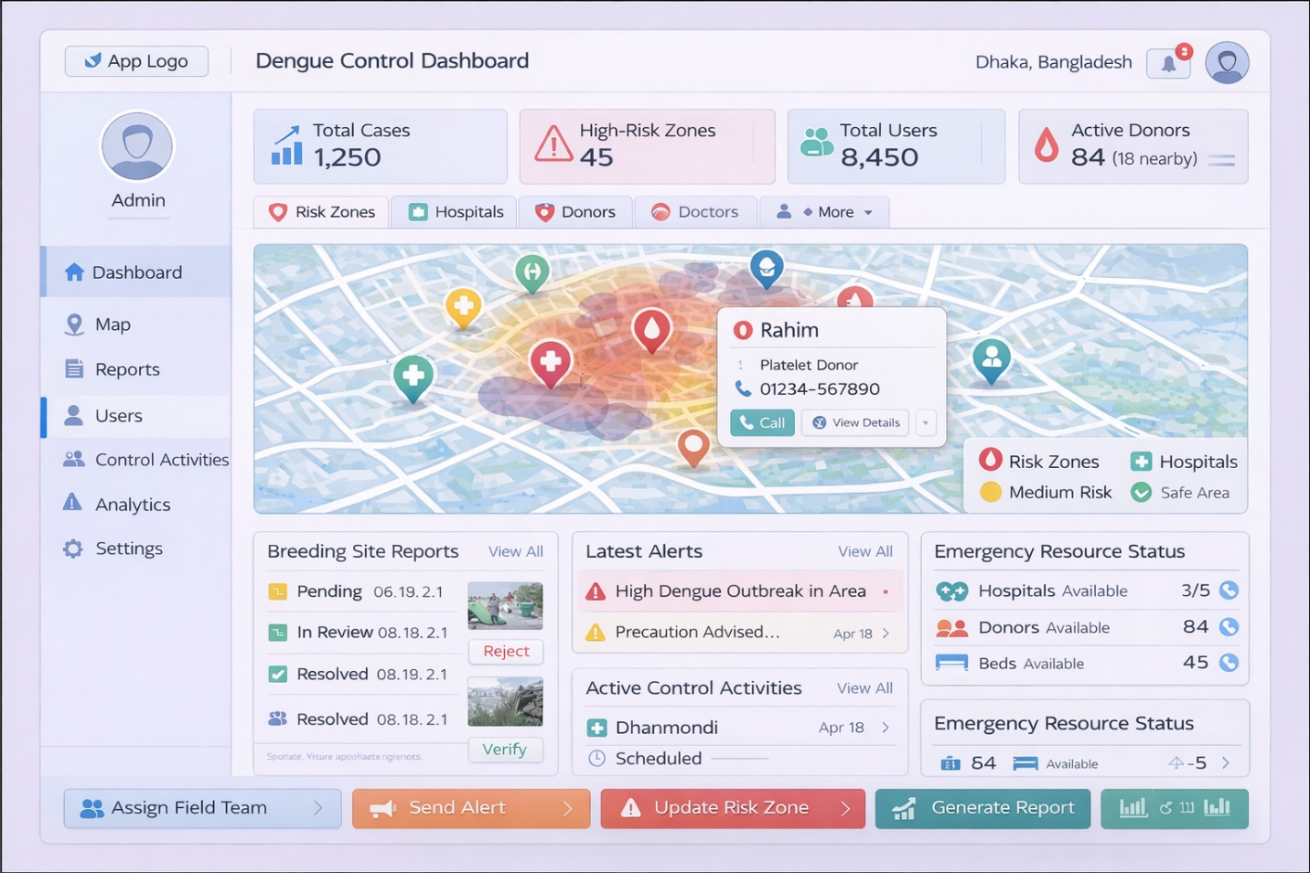

✅ Final Summary
👉 Admin dashboard দিচ্ছে:
✔ Monitoring
✔ Control
✔ Resource management
✔ Communication
✔ Data analytics
✔ Quick action
hospital user
🧠 1️⃣ Real-time Hospital Situation Awareness
👉 Hospital user instantly দেখতে পাচ্ছে:
- Dengue patients
- Available beds
- Critical cases
- Total doctors
- Emergency status
✔️ মানে:
👉 hospital এর current pressure clear
👉 decision নিতে easy

🗺️ 2️⃣ Smart Map Support (External Awareness)
👉 Map থেকে hospital user দেখতে পাচ্ছে:
- 🩸 Nearby donors
- 👨‍⚕️ Doctors
- 🏥 Nearby hospitals
- 🌈 Risk zones
✔️ Result:
👉 emergency হলে quickly donor খুঁজে পাওয়া
👉 nearby support system বোঝা

🩸 3️⃣ Donor Connection System (Very Important 🔥)
👉 Hospital করতে পারছে:
- Donor request send
- Donor details দেখা
- Direct call করা
✔️ Result:
👉 blood shortage problem fast solve
👉 patient survival chance বাড়ে

🛏️ 4️⃣ Smart Bed Management
👉 Hospital manage করতে পারছে:
- Total beds
- ICU beds
- Emergency beds
- Available beds
✔️ Citizen dashboard এ reflect হবে
✔️ Admin monitor করতে পারবে
👉 Meaning:
👉 resource transparency ✔️

🧑‍⚕️ 5️⃣ Doctor Management
👉 Hospital control পাচ্ছে:
- Doctor availability
- On duty / Off duty
- Contact info
✔️ Citizen doctor খুঁজতে পারবে
✔️ Admin health system বুঝতে পারবে

🧾 6️⃣ Patient Management
👉 Hospital দেখতে পাচ্ছে:
- New patients
- Discharged patients
- Severe cases
✔️ Patient flow track করা easy
✔️ ICU pressure বোঝা যায়

🚨 7️⃣ Emergency Control System
👉 Hospital করতে পারছে:
- Emergency status ON/OFF
- Notify admin
- Call authorities
✔️ Critical situation handle করা fast

🔔 8️⃣ Alert & Communication
👉 Hospital receive করছে:
- Admin alerts
- Outbreak warning
- Emergency notifications
✔️ Updated থাকে সবসময়

🔄 9️⃣ System Integration Benefit (Big Picture)
👉 Hospital এখন connected:
With Citizen:
- Bed availability show
- Doctor show
- Donor connect
With Admin:
- Data share
- Emergency update
- Resource request
✔️ Full ecosystem working ✔️

⚡ 10️⃣ Quick Action সুবিধা
👉 Dashboard থেকেই:
- Request donor
- Update emergency status
- Notify admin
✔️ Multiple system open করতে হচ্ছে না

🎯 11️⃣ Decision Making Easy
👉 Example:
- ICU beds low
- Critical patient high
- Donor nearby
👉 Hospital instantly:
- Donor call
- Admin notify
- Emergency mode ON
✔️ fast & smart action

🌍 12️⃣ Real Impact
👉 Hospital system use করে:
- patient manage করছে
- donor connect করছে
- admin কে inform করছে
👉 মানে:
✔ treatment + coordination + management
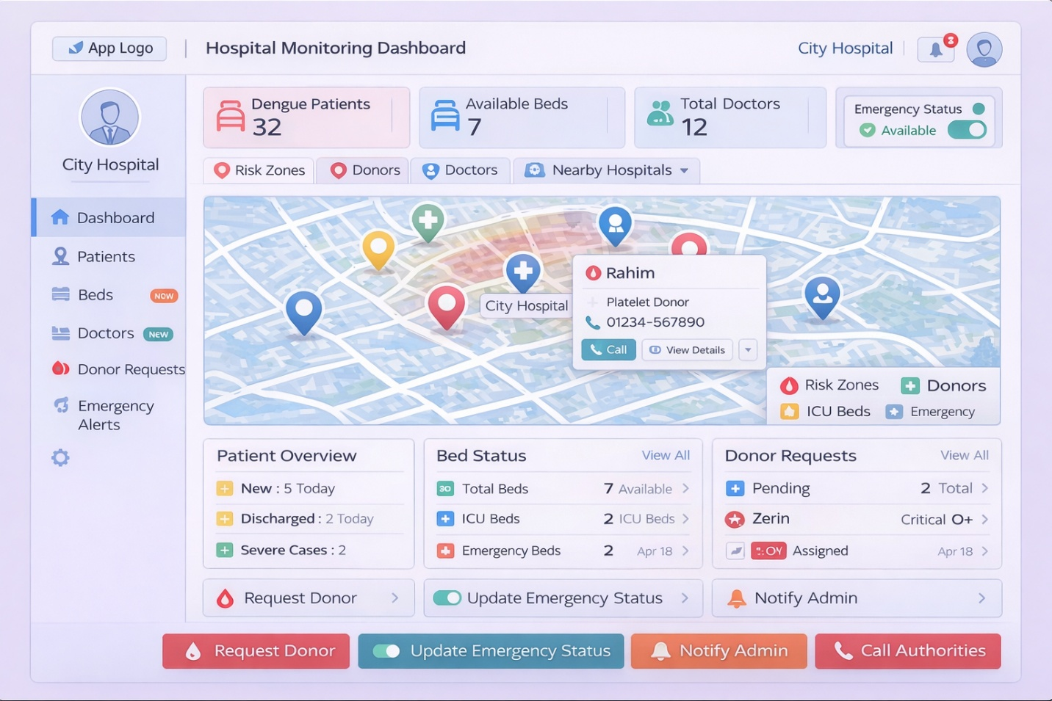
✅ Final Summary
👉 Hospital dashboard দিচ্ছে:
✔ Patient control
✔ Resource management
✔ Donor connection
✔ Emergency handling
✔ Real-time data
✔ System integration

